WhatsApp Facebook Developer Setup

- Login to below facebook developer app with the facebook login credentials and create APP

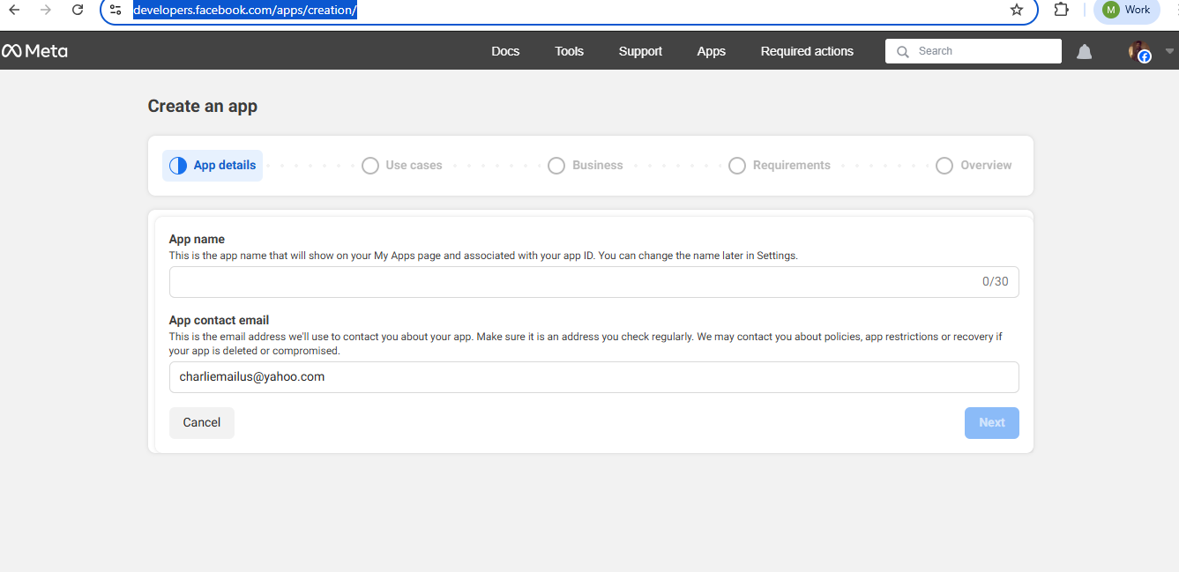

- Once you create the APP click and Proceed to the Dashboards

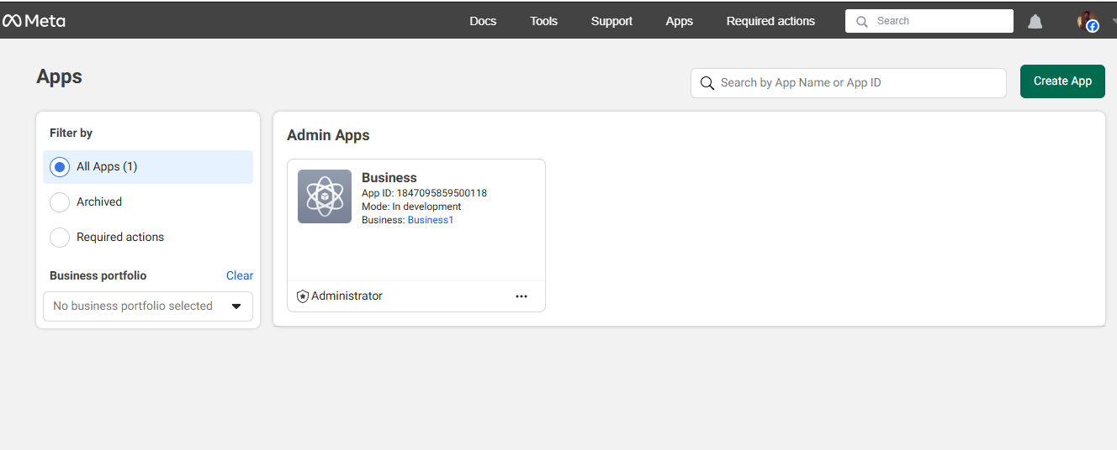

- Click the First Option “App customization and requirements”

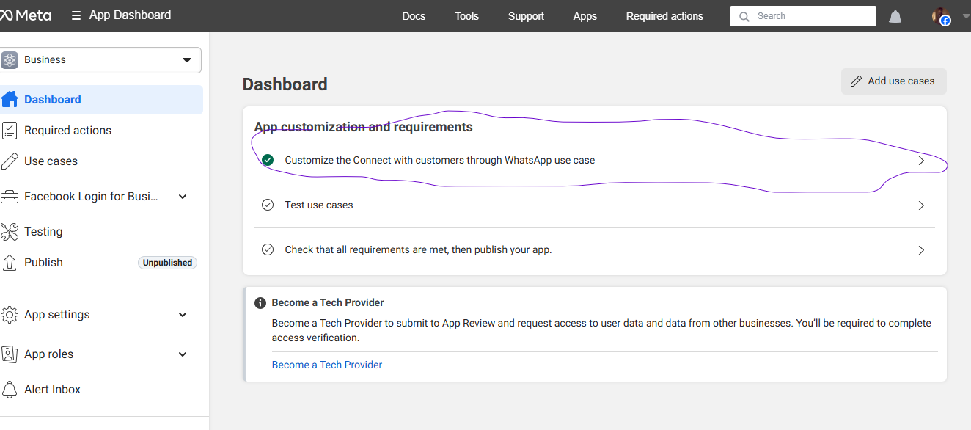

- Configuration is the key where we need to provide the Callback and Verify token and subscribe events - “Message” Event should suffice the Chatbot usecase.

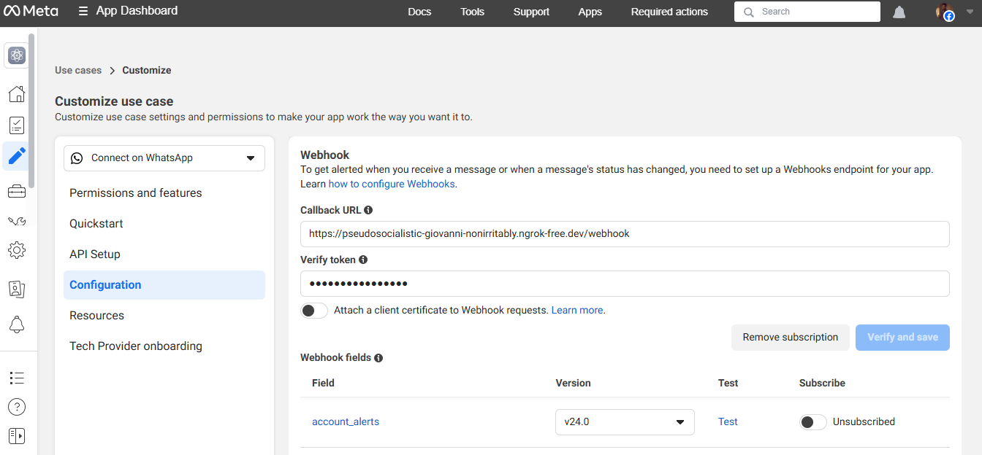

Note: This is the key and this is something we need to provide by running the Middleware layer in between.

Middleware Server

Middleware should be reachable from WhatsApp Meta and also to Olly tool ( NR ) - Used Ubuntu machine (WSL)

Create a new project folder:
mkdir whatsapp-webhook && cd whatsapp-webhook

Initialize Node project:
npm init -y

Install dependencies:
npm install express axios

Install ngrok (if not already):
sudo snap install ngrok

Start it:
ngrok http 3030

Note: Before starting the ngrok, We need to get the Authentication for setting up Ngrok

1. Sign up for an ngrok account (if you haven’t already)
Go to: 👉 https://dashboard.ngrok.com/signup
Create an account and log in.

🔹 2. Get your Authtoken
Once logged in, visit:
👉 https://dashboard.ngrok.com/get-started/your-authtoken
Copy the authtoken that looks like:
authtoken: 1A2b3C4d5E6F7g8h9I0JklMnOPq...

🔹 3. Install the authtoken on your system
Run this command in your terminal or command prompt:
ngrok config add-authtoken <your_authtoken_here>

Replace <your_authtoken_here> with the actual token you copied.
Example:
ngrok config add-authtoken 1A2b3C4d5E6F7g8h9I0JklMnOPq...

✅ Now re-run your ngrok command:
ngrok http 3030

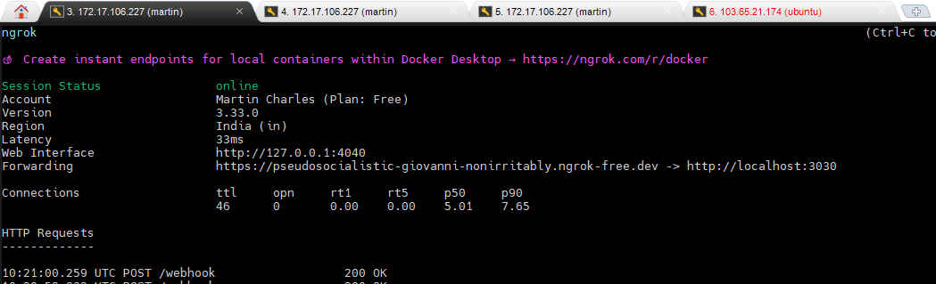

Whatever mentioned in the Forwarding is the Callback url and Verify token is the some challenge / text we need to give

https://pseudosocialistic-giovanni-nonirritably.ngrok-free.dev/webhook
Verify Token : test123

Before running the below code from Meta Dashboard→ API Setup Page , Provide the mobile number and token (temp or permanent) and send a message to your destined number, This will send communication from Meta to Whatsapp user and that test number chat will be the chat which you can respond back once you start running the below code.

🔹 4. Whatsapp_webhook_integration.js

Below is the list of variables along with the required information. The WhatsApp token, which can be a permanent token, must be configured or obtained from https://business.facebook.com/."

Variable | What It Represents | Where to Get It
PHONE_NUMBER_ID | Your WhatsApp Business API number ID | From WhatsApp Cloud API dashboard
WHATSAPP_TOKEN | Your WhatsApp Business permanent access token | Facebook Developer Console → App → WhatsApp
VERIFY_TOKEN | A token you set to verify the webhook | You define this in your code and console
NEW_RELIC_API_KEY | New Relic personal API key (NRAK...) | New Relic → API Keys
NR_ACCOUNT_ID | Your New Relic account ID | New Relic dashboard
NRQL query | The metric you want to query | Varies based on New Relic instrumentation

const PHONE_NUMBER_ID = "<WHATSAPP_PHONE_NUMBER_ID>";
const NEW_RELIC_API_KEY = "<YOUR_NEW_RELIC_API_KEY>";
const NR_ACCOUNT_ID = "<YOUR_NEW_RELIC_ACCOUNT_ID>";
const VERIFY_TOKEN = "<YOUR_WHATSAPP_VERIFY_TOKEN>";
const WHATSAPP_TOKEN = "<YOUR_WHATSAPP_AUTH_TOKEN>";

function convertDuration(input) {
if (input.endsWith('m')) return `${input.slice(0, -1)} minutes`;
if (input.endsWith('h')) return `${input.slice(0, -1)} hours`;
if (input.endsWith('d')) return `${input.slice(0, -1)} days`;
return input;
}

// ✅ Step 1: Handle webhook verification handshake
app.get('/webhook', (req, res) => {
const mode = req.query['hub.mode'];
const token = req.query['hub.verify_token'];
const challenge = req.query['hub.challenge'];

if (mode === 'subscribe' && token === VERIFY_TOKEN) {
console.log("✅ Webhook verified");
res.status(200).send(challenge);
} else {
res.sendStatus(403);
}
});

// ✅ Step 2: Receive incoming WhatsApp messages
app.post('/webhook', async (req, res) => {
const message = req.body?.entry?.[0]?.changes?.[0]?.value?.messages?.[0];
const from = message?.from;
const text = message?.text?.body;

if (text) {
console.log(`📥 Received: ${text}`);
let reply = `You said: ${text}`;

if (text.startsWith("/nrl")) {
const [_, metric, duration] = text.split(" ");
const converted = convertDuration(duration);
const nrql = `SELECT average(${metric}) FROM SystemSample SINCE ${converted} ago`;

const gqlQuery = {
query: `{
actor {
account(id: ${NR_ACCOUNT_ID}) {
nrql(query: \"${nrql}\") {
results
metadata {
facets
}
}
}
}
}`
};

try {
const nrResponse = await axios.post(
"https://api.newrelic.com/graphql",
gqlQuery,
{
headers: {
"Content-Type": "application/json",
"API-Key": NEW_RELIC_API_KEY
}
}
);

console.log("📡 NR Raw Response:", JSON.stringify(nrResponse.data, null, 2));
const results = nrResponse.data?.data?.actor?.account?.nrql?.results;

if (results && results.length > 0) {
const formatted = results.map((r, i) => `${i + 1}. ${JSON.stringify(r)}`).join("\n");
reply = `📊 ${metric} results:\n${formatted}`;
} else {
reply = `⚠️ No results returned for query.`;
}
} catch (err) {
console.error("❌ New Relic API Error:", err.response?.data || err.message);
reply = "⚠️ Failed to fetch data from New Relic.";
}
}

const payload = {
messaging_product: "whatsapp",
to: from,
text: { body: reply }
};

console.log("Sending payload to WhatsApp:", payload);

try {
await axios.post(
`https://graph.facebook.com/v17.0/${PHONE_NUMBER_ID}/messages`,
payload,
{
headers: {
Authorization: `Bearer ${WHATSAPP_TOKEN}`,
'Content-Type': 'application/json'
}
}
);
} catch (error) {
console.error("❌ Axios error:", error.response?.data || error.message);
}
}

res.sendStatus(200);
});

// 🟢 Start server on port 3030
app.listen(3030, () => console.log("🌐 Webhook server running on port 3030"));

app.get('/', (req, res) => {
res.send("Webhook server is live!");

});
NR_ACCOUNT_ID | Your New Relic account ID | New Relic dashboard
NRQL query | The metric you want to query | Varies based on New Relic instrumentation
Now run both the above ngrok http 3030 & node whatsapp_webhook_integration.js on two separate tabs , so that it runs independently and now as per the logic written in the code , when the user types /nrl <command> from the whatsapp chat , it will send the Meta and the Meta in turn calls the webhook API. Below is the flow

WhatsApp (User)
⬇
WhatsApp Cloud API (Meta)
⬇
Your Webhook API (Node.js / Flask)
⬇
Command Parser (e.g. /nrl apdex svc 15m)
⬇
Call New Relic NerdGraph API
⬇
Reply back to user via WhatsApp Cloud API

